|  |  |
| --- | --- |
| Team ID | PNT2022TMID31884 |
| Project Name | Project - **Personal Assistance for Seniors Who Are Self-Reliant** |

**Create text to speech service**

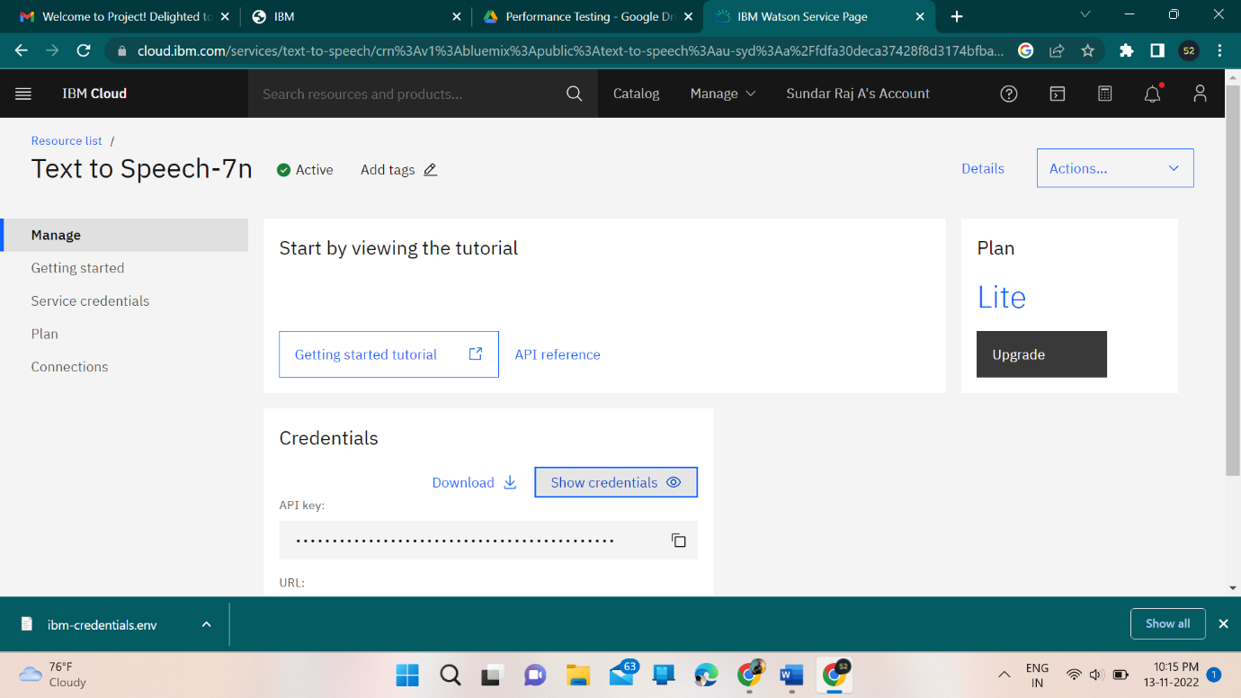

**Create data base in Cloudant db**

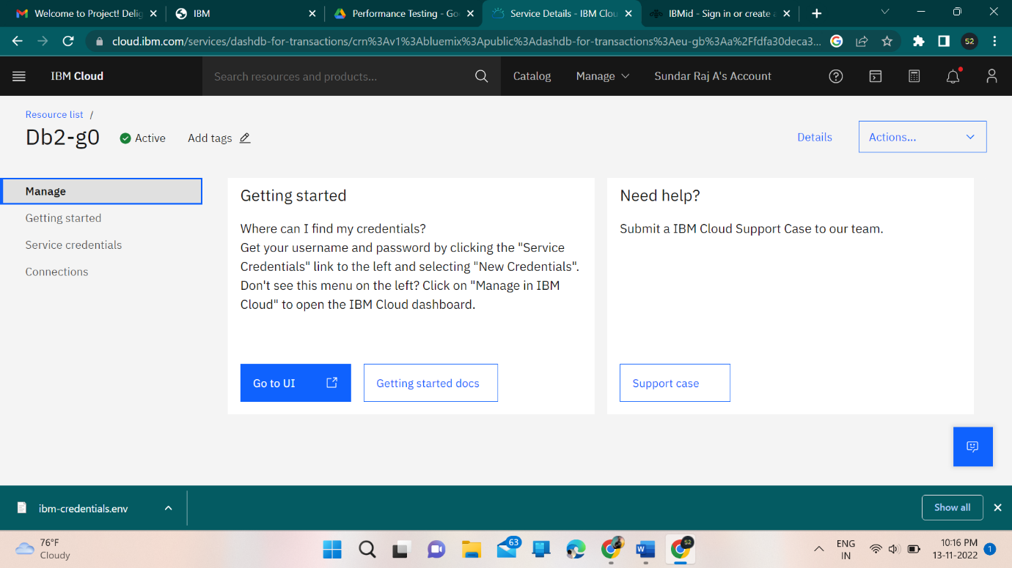

**Create IBM Watson IoT platform & device**

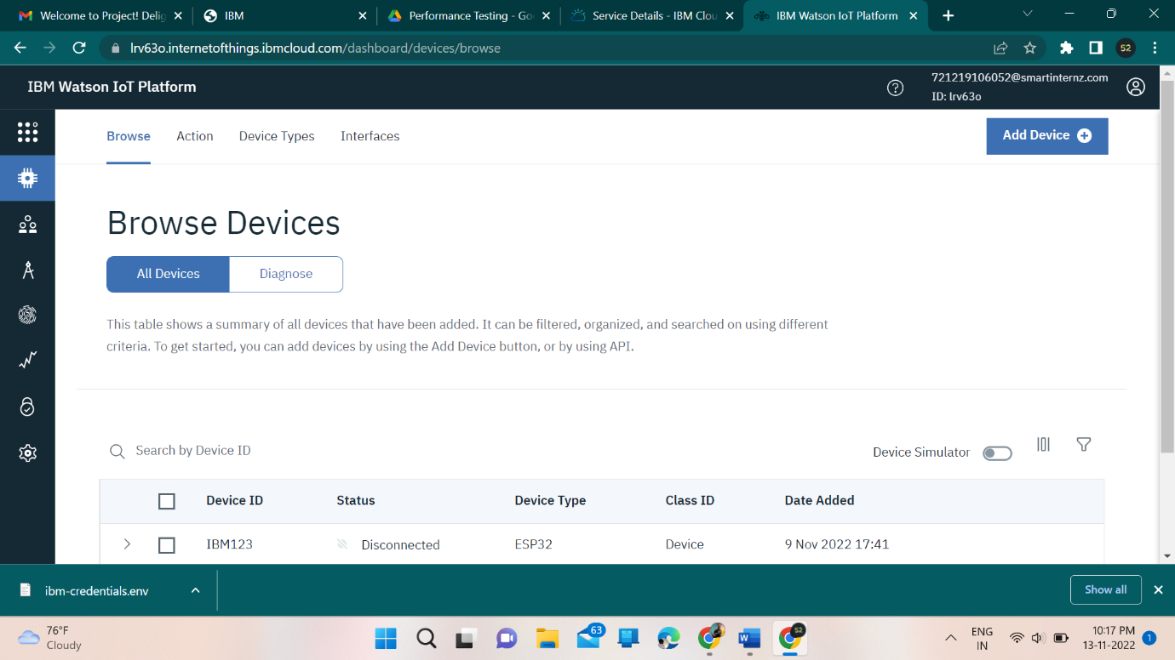

**Create node-red service**

